
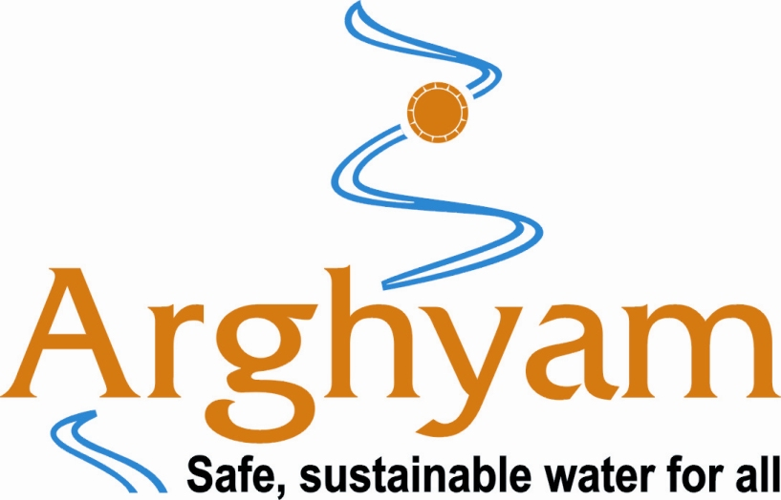

07, September 2009

Sub: Invitation to be the Expert for the Brainstorming workshop on Ensuring Water Services for the rural people of Bundelkhand on September 15th and 16th at TARAgram Orchha, Madhya Pradesh
Dear ,
Greetings from Development Alternatives!
In the wake of severe drought in the Bundelkhand region, Development Alternatives and Arghyam Trust launched an initiative ‘Water for All and Always’ in 2006 in ten project villages of Jhansi and Tikamgarh districts to address the need of an Integrated Water Resources Management. The key sustainable features of the project are ‘community participation’, safe and sustainable drinking water solutions.
‘Water for All and Always’ is a significant step towards finding appropriate solutions in meeting the qualitative and quantitative requirements of basic services like water and sanitation in rural regions of Bundelkhand.The project is designed to provide solutions for an Integrated Domestic Water Management and drawing lessons for multiplication.
The ‘Water for All and Always’ project has completed 3 years of its implementation and during its course of journey, there were several process learning, challenges and lessons that can be used for effective planning and implementation of similar initiatives in the region and also in other geographies of similar nature.
With intent of sharing the lessons learnt, get valuable inputs and feedback on the process and model of Integrated Domestic Water Management (IDWM), Development Alternatives with the support of Arghyam Trust is organising a 2 day workshop from 15th to 16th September 2009 at TARAgram, Orchha, Madhya Pradesh.
The workshop will provide a common platform of engagement to individuals, government, organisations, institutions and policy makers. The idea of holding the workshop in Bundelkhand region is to catalyse the local action.
The workshop is expected to come out with a declaration on critical issues of water for influencing sustainable policy at state and national level. During the course of the workshop, a compendium of case studies, GIS Based Knowledge Product and a Film on the project will be released.
We believe that your experience would add great value to the workshop and to an improved understanding of integrated domestic water management in rural areas.
May I invite you to be the Expert for the workshop is taking place from September 15th to 16th at TARAgram, Orchha, Madhya Pradesh.
For any clarifications, please feel free to contact at:
Mobile No.: 92356 67461/ 94500 80811/9891016966
Email: skulshrestha@devalt.org ,mkumar@devalt.org
We look forward to a positive response at your earliest on your participation.

Yours sincerely,
M.Manoj Kumar
Programme Manager, Water Programme
Development Alternatives, New Delhi
111/ 9 Z, Kishangarh, Vasant Kunj, New Delhi-110070
www.devalt.org

